The aim of blood film reporting should be to provide a reliable and consistent description of a patient's blood film. These notes are provided to standardize comments made on blood film reporting and are based upon the NZIMLS standardised reporting of blood film morphology 2011 and the ICSH recommendations for the standardisation of nomenclature and grading of peripheral blood cell morphological features 2015.

It is also helpful that the scientist comment demonstrates context, a thought process and communicates with the next morphologist any significant features or diagnosis eg “*Red cells are irregular. White cells are dysplastic. Platelets are normal. Known lung transplant. ?Therapy related changes”, d*emonstrates an awareness of the clinical setting and morphology changes are interpreted in context of the underlying condition or treatment.

Morphologists are expected to describe red blood cells (RBCs) white blood cells (WBCs) and platelets on the report form. It is not permitted to use generalised phrases such as “No changes seen” in a blood film report.

It is also expected that all cell lines are reported each day. It is unhelpful to observe red cell changes in the absence of historic red cell morphology comments. eg it is impossible to know if fragments have been seen before or are increasing or decreasing in number if there is no previous red cell comment.

Variation in RBCs, WBCs and platelet morphology is common and the ability to recognize the abnormalities comes with experience. The grading of morphology elements should provide the clinician with useful information regarding the status of any abnormality in the peripheral blood. The Alfred Pathology Services morphology grading table included contains a three-tiered grading system, for 1+ (mild increase), 2+ (moderate increase) and 3+ (many) based on a combination of the NZIMLS and ICSH guidelines. The designation (few/rare/occasional) is reserved only for schistocytes or tears drop cells, as the observation even in small numbers is clinically significant.

**The Alfred Pathology Services table is based on the NZIMLS and ICSH morphology grading tables**

**Refer to table 2 for common red cell synonyms**

Examination of a blood film requires that a 'good area" of the film be examined. If the spreading, staining or artefact changes do not allow for proper examination a new film must be obtained. If we cannot obtain a suitable film for review consider the following- look for another specimen, result as unsuitable, make an albumin slide, make appropriate comment or refer to senior scientist.

Reports on blood films are made via either Remisol or PathNet. All reports should be constructed using comments already predefined in the “type it in” software. Free text may be used where required, however, if a required text or phrase is missing please discuss this with the morphology senior. All reports should be reviewed by the morphologists for errors and spelling check prior to verification.

Patient history should be viewed through various means listed:

1. Powerchart which goes back to 2000, contains all active UR numbers for a patient and all corrected reported results.
2. Results and result flagging can be seen in Remisol archives but frequently do not reflect the final powerchart result.

**Table 1 ICSH**

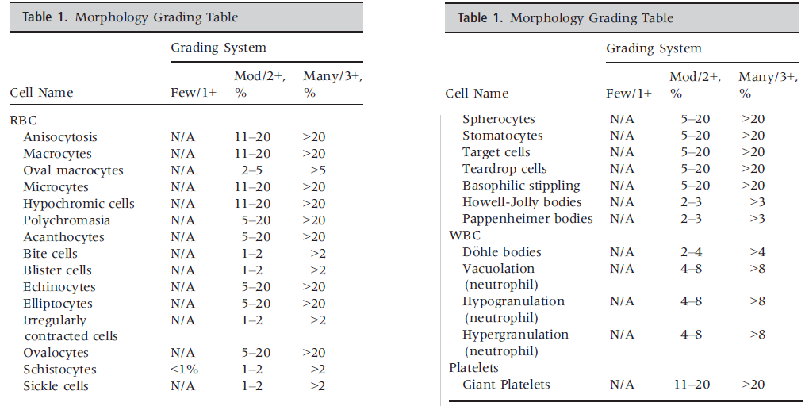

**Table 1 NZIMLS**

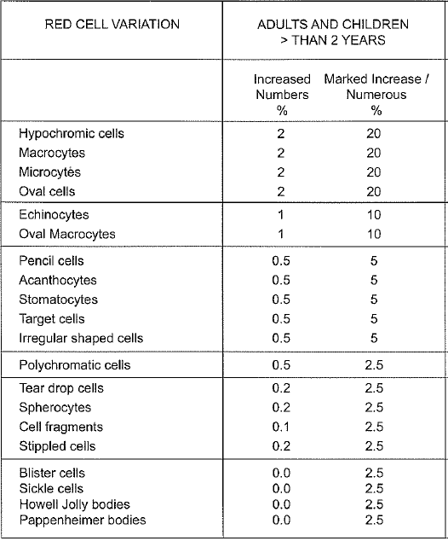

|  |  |  |  |  |
| --- | --- | --- | --- | --- |
| **Alfred Pathology Services** |  |  |  |  |
| **RBC %** | Occasional | Mild | Moderate | Marked |
| Macrocytes | N/A | 2-<11 | 11-20 | >20 |
| Microcytes | N/A | 2-<11 | 11-20 | >5 |
| Hypochromic cells | N/A | 2-<11 | 11-20 | >20 |
| Polychromasia | N/A | 0.5-<5 | 5-20 | >20 |
| Acanthocytes | N/A | 0.5-<5 | 5-20 | >20 |
| Bite cells | N/A | <1* | 1-2 | >2 |
| Blister cells | N/A | <1 | 1-2 | >2 |
| Echinocytes | N/A | 1-<5 | 5-20 | >20 |
| Elliptocytes | N/A | 2-<5** | 5-20 | >20 |
| Irregular contracted cells | N/A | <1*** | 1-2 | >2 |
| Oval cells | N/A | 2-<5 | 5-20 | >20 |
| Oval Macrocytes | N/A | 1-2 | 2-5 | >5 |
| Schistocytes | <0.1 | 0.1-<1 | 1-2 | >2 |
| Sickle cells | N/A | <1 | 1-2 | >2 |
| Spherocytes | N/A | 0.2-<5 | 5-20 | >20 |
| Stomatocytes | N/A | 0.5-<5 | 5-20 | >20 |
| Target cells | N/A | 0.5-<5 | 5-20 | >20 |
| Teardrop cells | <0.2 | 0.2-<5 | 5-20 | >20 |
| *Basophilic stippling* | *N/A* | *<5* | *5-20* | *>20* |
| *Howel-Jolly bodies* | *N/A* | *<2* | *2-3* | *>3* |
| *Pappenheimer bodies* | *N/A* | *<2* | *2-3* | *>3* |
| **WBC** |  |  |  |  |
| *Dohle bodies* | *N/A* | *<2* | *2-4* | *>4* |
| *Neutrophil vacuolation* | *N/A* | *<4* | *4-8* | *>8* |
| *Neutrophil hypogranulation* | *N/A* | *<4* | *4-8* | *>8* |
| *Neutrophil hypergranulation* | *N/A* | *<4* | *4-8* | *>8* |
| **PLT** |  |  |  |  |
| Giant Platelets | N/A | <11 | 11-20 | >20 |

*=Blister cells % used **=oval cells % used ***=Blister cells % used

**Helpful tip**

A x40 field of view generally has about 600 red cells.

1% would equate to 6 per field,

5% would equate to 30 per field,

10% would equate to 60 per field and

>20% would equate to >120 per field.

**NO grading of WBC changes, basophilic stippling, Howell-Jolley bodies or Pappenheimer bodies are required.** *Values are present but greyed out.*

**Table 2**

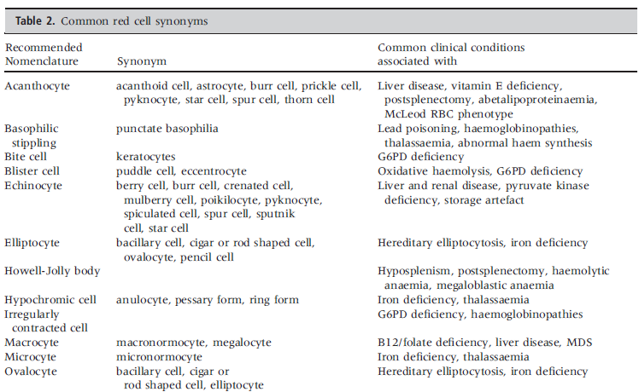

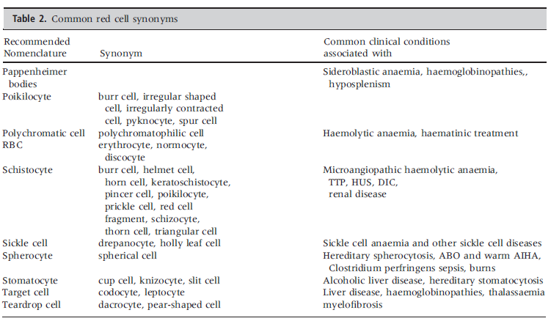

# RED BLOOD CELLS

The important considerations are of size, shape and haemoglobin content. Detailed recording of minor variations is unnecessary.

## RED BLOOD CELL SIZE AND SHAPE

### ANISOCYTOSIS – Not reported in this laboratory

Anisocytosis is an increased variability in RBC size. It is nonspecific and will be reflected in an increased red cell distribution width (RDW) in automated analyser counts.

The recommendation is to use and report the RDW as a measure of the degree of variation in red cell size. We do not report anisocytosis but focus on morphologic size descriptors.

The XN analysers generate %micro and %macro on all FBE’s. In the future %Micro and %Macro may be used as a guide for adult blood film reporting. Values to follow once analysers fully implemented.

### MICROCYTOSIS

Microcytes are small red blood cells with a diameter of less than 7 µm (MCV < 80 fL). The red cells of newborns and neonates are larger than in adults but the red cells of healthy children are physiologically smaller than in adults so it important that red cell size be interpreted in the context of the age of the subject. It is recommended that the more accurate analyser generated parameters MCV and %Micro be used in conjunction with the RDW to gauge red cell size (degree of microcytosis)

An abnormal RDW or red cell histogram that suggests the presence of microcytes even though the MCV is normal may also prompt slide review and grading of microcytes by visual microscopic examination. It should be noted that moderate numbers of target cells will falsely lower the MCV due to their increased surface area to volume ratio. The degree of microcytosis should correlate with the MCV, extreme discrepancies require careful review.

False microcytic analyser parameters may be seen in disturbed electrolyte balance such as low Sodium. This may also affect the MCHC and should be considered in the context of high MCHC trouble shooting and morphological reporting

### MACROCYTOSIS

Macrocytes are enlarged red cells with a diameter greater than 8.5 µm, (MCV > 100 fL). The MCV will be elevated but the MCH will be normal or elevated if there is a significant increase in MCV. They may be round or oval in shape which can have diagnostic significance. It is noteworthy that red cells in premature, newborn babies and neonates are physiologically larger than in adults. Reticulocytosis may also cause an elevated MCV. It is recommended that the more accurate analyser generated parameters MCV and %Macro be used in conjunction with the RDW to gauge red cell size (degree of macrocytosis) rather than grading by visual microscopic

examination. However, if oval macrocytes are present, it is recommended that these be graded.

False macrocytic analyser parameters may be seen in disturbed electrolyte balance such as high Sodium, diabetic ketoacidosis and drip contamination of edta samples. This may also affect the MCHC and should be considered in the context of low MCHC trouble shooting and morphological reporting.

### HYPOCHROMIA

Hypochromia is a reduction in RBC staining with an increase in central pallor to greater than one-third of the RBC diameter. The reduction of the MCV and/or MCH can be sensitive indicators of hypochromic cells. It is recommended that the analyser generated MCH/MCHC be used to gauge hypochromia rather than grading by visual microscopic examination.

The presence of hypochromia with a normal MCV and/or MCH should be reviewed.

Exceptions are to be found e.g.:

1. Patients with liver disease often have large thin cells with a high MCV and appear microscopically to have hypochromia.

A population of hypochromic cells amongst a population of normochromic cells constitutes a dimorphic blood film. If hypochromia is recorded the cells cannot also be normochromic unless a dimorphic population of cells is present.

### POLYCHROMASIA

Polychromatic cells appear in normal films and the term "occasional polychromatic cell" should not be used. Specimens that show significant polychromasia should also have a reticulocyte count. The presence of polychromasia does not preclude the term normocytic being used. Macrocytosis due to polychromatic cells is not commented upon.

### ROULEAUX (MODERATE OR MARKED)

Rouleaux formation (red cells stacked up like a pile of coins) usually occurs when plasma protein concentrations are high i.e. myelomas. This abnormality should be definite to be recorded. Discrepancies between the degree of rouleaux and the ESR result should be avoided e.g. a large degree of rouleaux with an ESR of 1 mm in 1 hour. If such discrepancies occur repeat the Film and ESR on same specimen and if still discrepant further advice should be sought. Some other causes of rouleaux include extreme anaemia and infection.

### AGGLUTINATION (REPORT THE PRESENCE OF)

Agglutination is the irregular clumping of red blood cells into grape like clusters, usually indicating the presence of a cold reactive anti-RBC antibody (i.e. anti I). A falsely increased MCV and falsely reduced RBC count will be obtained (in high avidity cold antibodies) leading to spurious elevations in the MCH and MCHC. First observation of red cell agglutination should be referred to the registrars.

### POIKILOCYTOSIS

Poikilocytosis means variation in shape. The term **poikilocytosis should not be used**- always describe the more specific shape. Minor degrees of poikilocytosis or that is obviously artefactual, e.g. crenation as seen in aged EDTA specimens, should not be recorded.

The terms to be used to describe poikilocytosis include all listed in table 1.

Below are some red cell shapes listed in Table 1.

1. **Schistocytes=Fragments**

Schistocytes are always smaller than intact red cells and can have the shape of fragments with sharp angles and straight borders, small crescents, helmet cells or keratocytes.

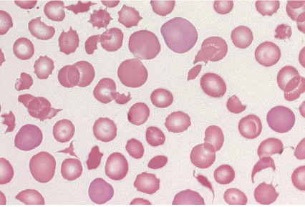

Schistocytes are always

smaller than intact red cells and can have the shape of

fragments with sharp angles and straight borders, small

crescents, helmet cells or keratocytes.

1. **Irregularly contracted cells.**

As seen in unstable haemoglobins. Irregularly contracted cells are smaller and denser RBC which lack an area of central pallor but are not as regular in shape as spherocytes

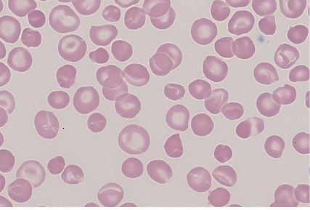

Irregularly contracted cells are smaller and denser

RBC which lack an area of central pallor but are not

as regular in shape as spherocytes

1. Bite cells

Bite cells are RBC with peripheral single or multiple arcuate defects (bites) caused by the removal of Heinz bodies by the spleen and are a feature of oxidant haemolysis.

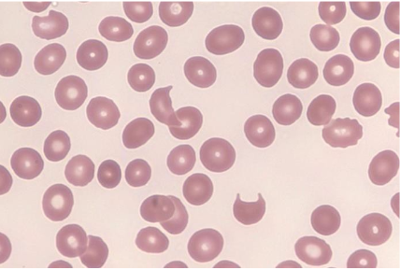

1. Blister cells

Blister cells are red cells in which the haemoglobin appears retracted into one half of the cell to form a dense mass leaving the remainder of the cell as an empty membrane.

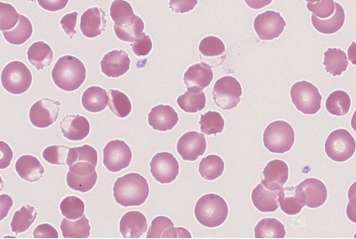

Blister cells are red cells in which the haemoglobin

appears retracted into one half of the cell to form a

dense mass leaving the remainder of the cell as an

empty membrane.

1. **Elliptocytes and ovalocytes/ elongated/ pencil**

**Ovalocytes** have an oval shape with the long axis is less than twice the short axis

**Elliptocytes** are cells with an elliptical shape with a long axis more than twice the short axis

**Pencil** cells are hypochromic and elongated with a long axis more than three times the short axis

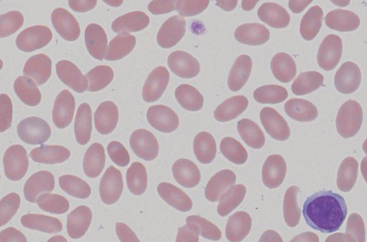

Elliptocytes are cells with an elliptical shape (the

long axis is more than twice the short axis), while

ovalocytes have an oval shape (the long axis is less

than twice the short axis).

1. **Crenated cells** (Echinocytes)- continue to use crenated cells.

Echinocytes are red cells that have lost their disc shape and are covered with 10-30 short blunt projections or spicules of fairly regular form.

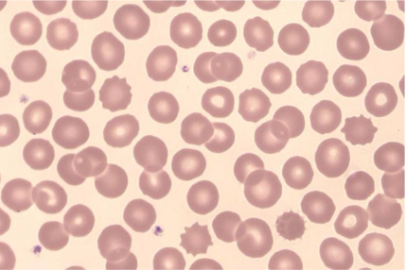

1. **Acanthocytes**

Acanthocytes are round, hyperchromic red cells with 2-20 irregularly spaced projections or spicules of variable length, thickness and shape. Some spicules have club-shaped rather than pointed ends.

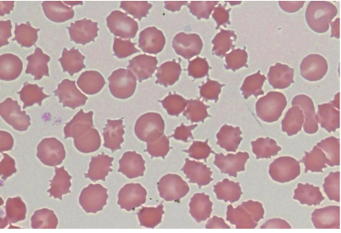

Acanthocytes are round, hyperchromic red

cells with 2-20 irregularly spaced projections or

spicules of variable length, thickness and shape.

Some spicules have club-shaped rather than pointed

ends.

1. **Target cells**

Target cells are thin cells with an increased surface area to volume ratio that have an area of increased staining which appears in the middle of the area of central pallor. Target cells are seen e.g. post splenectomy, liver disease and in thalassaemia but may also be artefact.

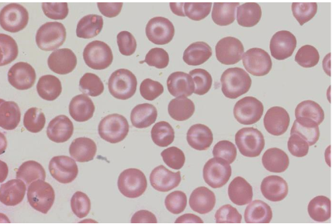

1. **Tear drop cells** with “blue” polychromasia

Teardrop cells are red cells that are pear or teardrop in shape.

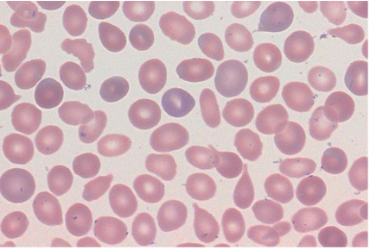

1. **Stomatocytes**

Stomatocytes are uni-concave cup-shaped red blood cells that appear on a stained blood ﬁlm with a slit-like area of central pallor.

In **South East Asian ovalocytosis**, the Stomatocytes have two stomas per cell which maybe longitudinal, transverse, V or Y shaped.

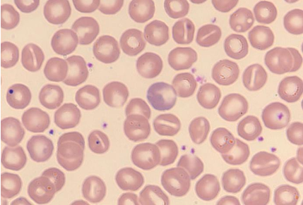

1. **Spherocytes / Microspherocytes**

**Spherocytes** are of small diameter (<6.5 µm) and are dense spheroidal RBC with a normal or decreased MCV and an absence of central pallor. They may be formed as a consequence of an abnormality of the RBC cytoskeleton and membrane, immune and microangiopathic haemolysis and direct damage to the red cell membrane. Spherocytes must be present in a well-spread, well stained area of the film

**Micro-spherocytes** are mainly described in burns patients.

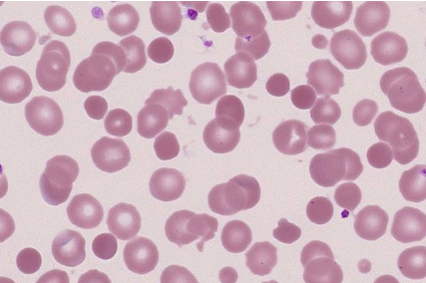

1. **Sickle cells**

Sickle cells are red cells that become crescent or sickle-shaped with pointed ends as a result of polymerization of HbS.

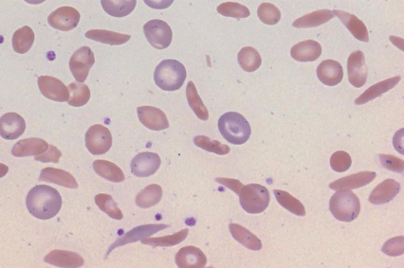

RED CELL INCLUSIONS

### **Red Cell inclusions**

1. **Howell Jolly Bodies**

Howell-Jolly bodies are usually single, small (1 lm), dense, perfectly round basophilic inclusions that are fragments of nuclear material (DNA).

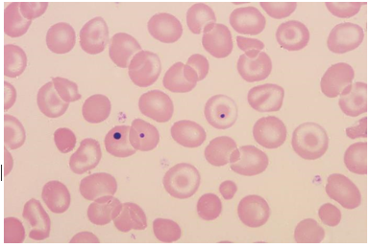

1. **Pappenheimer bodies**

Pappenheimer bodies (ferritin aggregates) in red cells contain small basophilic inclusions of variable size and shape in a limited cytoplasmic area

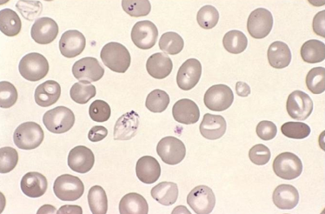

**Basophilic stippling**

Basophilic stippling describes the occurrence of ﬁne, medium, or coarse blue granules due to abnormally aggregated ribosomes, uniformly distributed throughout the RBC.

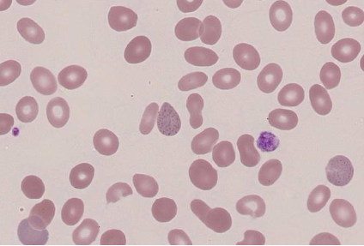

1. **Nucleated red blood cells (NRBC)**

A nucleated red blood cell is a red cell precursor and is used to describe an erythroblast in the peripheral circulation. Where NRBC are present at 1 per 100 WBC or more they are to be reported in the differential as an absolute count.

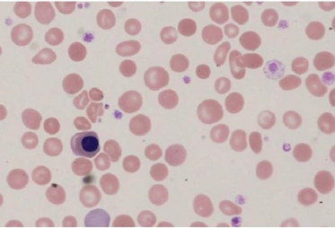

## Hyposplenic changes

If the first-time presentation of a film shows asplenic changes (i.e. targets, Howell-Jolly bodies, Pappenheimer bodies) then these should be fully described in the red cell comment.

A comment of asplenic changes is sufficient comment; providing the changes have already been recorded in detail and there is no significant change from a previous report**.**

**Cells which are not normally associated with asplenic changes should continue to be reported.**

**The first-time presentation of asplenic changes must be passed over to the registrars to be reviewed** and if necessary included in the splenic register.

# WHITE BLOOD CELLS (WBCs)

The validity of the WCC must always be checked against the number of WBCs that appear on a blood film. All WBC types are given absolute numbers. White cell differentiation involves the classiﬁcation of white cells based on size, nuclear shape, chromatin pattern and cytoplasmic appearance and content.

## White blood cell ranges and differentials

### Comment range

Generally, the presence of an absolute increase or decrease in any white cell type must be noted but any indication of the degree of change does not need comment.

Neutropenia: <1.5 x 109/L Neutrophilia: >8.0 x 109/L

Lymphopenia: <0.5 x 109/L Lymphocytosis: >4.0 x 109/L

Monocytosis >1.5 x 109/L

Eosinophilia: Mild degrees are not commented on.

Eosinophil counts above 1.0 x 109/L state "Eosinophilia".

Discrepancies between the blood film appearance of WBC numbers and the automated WCC should be repeated and if confirmed referred to a Senior Morphologist.

### WBC differentials

Should a manual differential be necessary or in the place of the analyser differential the statistical inaccuracies of the 100 cell differential must be borne in mind. A manual differential is necessitated if the cells need to be reported that the analyser is unable to classify or the morphologist is in disagreement with the analyser count.

In the case of **Chronic Lymphocyte Leukaemia** (CLL) a manual differential is only required if the number of prolymphocytes appear to be more than 10% or cells appear to have been misclassified eg as basophils. A 200-cell differential should be attempted in these cases.

Large numbers of smear cells may be seen in CLL peripheral blood films. If a manual differential is required, you can add 1 drop of albumin (approx. 20%) to 4 drops of blood to maintain cell integrity. It is recommended that the automated count differential be reported if available when the nature of the smear cell is apparent. It is recommended that they should be counted as the cell from which they are derived. Failure to count smeared lymphocytes in the differential may falsely elevate the neutrophil count and mask a true neutropenia.

In very low white cell counts i.e. <1.0 and a manual differential is required to differentiate abnormal cell lines you can count 50 cells in the diffpad mode by replacing the 100 with 50. Action these through differential only, verify and then complete through comments only. This is done in rare cases as required. It should be stated in the morphology comment that decreased numbers of cells were counted.

## MORPHOLOGY

### **LYMPHOID LINE**

### **LYMPHOCYTES**

Lymphocytes seen in the PB are predominantly small (10-12µm) or less frequently large (12-16µm). Small lymphocytes are usually round and the nucleus is also round with coarse, densely staining chromatin. Cytoplasm is scanty. Large lymphocytes are usually irregular in outline, and the nuclear chromatin is not as coarse as in the small lymphocytes. Cytoplasm is abundant and tends to be light sky blue in colour. Lymphocytes predominate in the blood ﬁlms of infants and children until 4 years of age. These lymphocytes are more pleomorphic than those seen in normal adult blood ﬁlms.

### **REACTIVE LYMPHOCYTES**

Lymphocyte morphology is subject to wide variability due to various immunological stimuli both in inﬂammatory and infectious diseases (particularly viral) as well as in neoplastic disorders (leukaemias and lymphomas), resulting in circulating lymphocytes with morphological abnormalities in various quantities. **The term atypical lymphocyte is no longer used.** The recommendation is to comment on the presence of reactive lymphocytes. They may be counted as a separate population in the differential if they are present in signiﬁcant numbers. It is recommended that reactive lymphocyte is used to describe lymphocytes with a benign aetiology and **abnormal** lymphocyte with an accompanying description of the cells is used to describe lymphocytes with a suspected malignant or clonal aetiology.

1. Reactive lymphocytes as seen in viral illness.

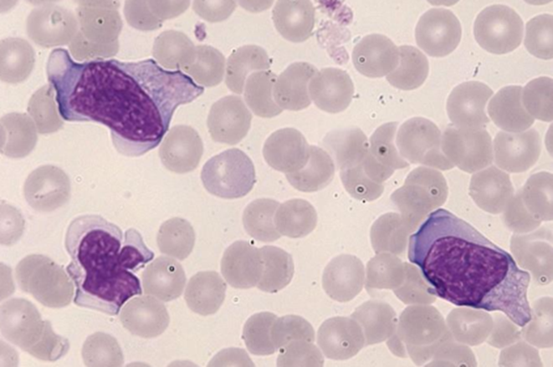

### **ABNORMAL LYMPHOCYTES**

1. Abnormal lymphocytes as seen in follicular lymphoma  
   as defined by immunophenotyping

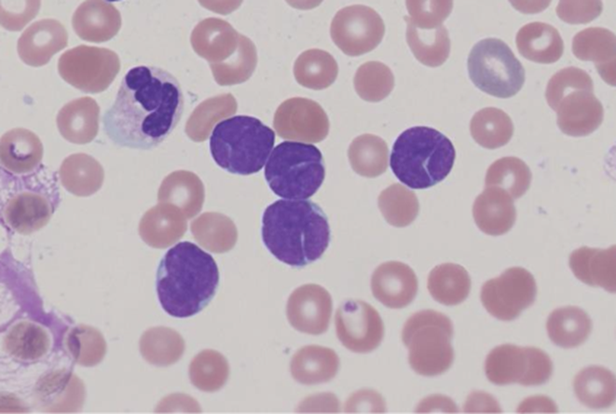

It is recommended that if the diagnosis is unknown then lymphoma cells are counted as abnormal lymphocytes on ﬁrst presentation with a detailed description of the cells included in the ﬁlm comment. After immunophenotyping the cells may be counted as lymphoma cells in the WBC differential.

### **PROLYMPHOCYTES**

B-prolymphocytes are twice the size of a lymphocyte and have a round nucleus, moderately condensed nuclear chromatin, a prominent central nucleolus and a relatively small amount of faintly basophilic cytoplasm.

1. B-prolymphocytes

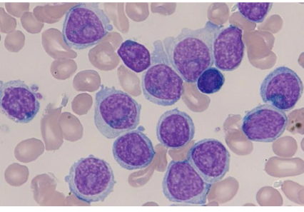

### **LARGE GRANULAR LYMPHOCYTES**

### Large granular lymphocytes (LGLs) are of the same appearance as large lymphocytes but the cytoplasm contains prominent small red-violet granules. These cells can comprise up to 10-20% of the peripheral blood lymphocytes in normal films. LGL are not routinely counted as a separate lymphocyte population BUT maybe commented on if they are present in increased numbers. This may prompt investigations such as flow cytometry.

1. Large granular Lymphocytes

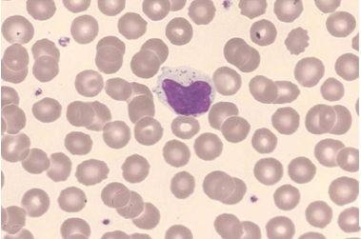

### 

### **LEUKAEMIC LYMPHOBLASTS**

Leukaemic lymphoblasts range from those with a high N:C ratio, clumped chromatin, inconspicuous nucleoli and scanty basophilic cytoplasm to those that are heterogenous in appearance and have a nuclear chromatin pattern varying from ﬁnely dispersed to coarsely condensed. The nuclear outline may be irregular and nuclear clefting indentation and folding are common. Nucleoli vary in size and number but are often indistinct. A small number of lymphoblasts may have more abundant cytoplasm containing coarse azurophilic granules. **Lymphoblasts cannot be reliably distinguished from myeloid blasts, lymphoma cells and sometimes, reactive lymphocytes.** Additional information from immunophenotyping may be required to make an accurate diagnosis. The recommendation is to count and report these as blasts and describe them in the ﬁlm report.

## NEUTROPHILS

### **Segmented neutrophils** usually have 3–4 lobes (occasionally 2 and 5 lobes). A segmented neutrophil is defined as a cell in which the lobes of the nucleus are connected by a filament or a segment of nuclear material that is less than one third the width of the thinnest lobe in the neutrophil.

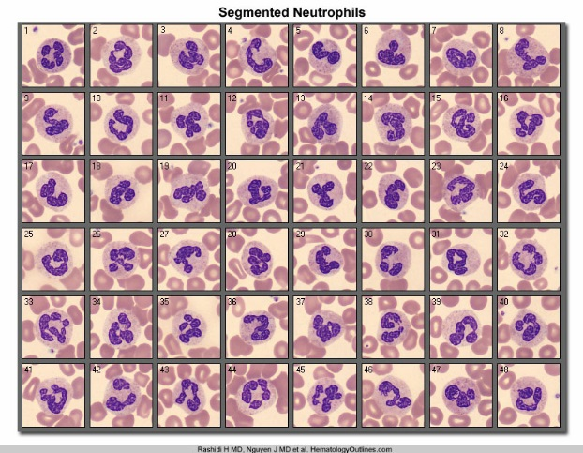

### **Hypersegmented neutrophils** have an increased number of distinct nuclear lobes with increased numbers of neutrophils having 5 or more nuclear segments. Neutrophil hypersegmentation is deﬁned as

### any neutrophil having 6 or more lobes

### more than 3% of neutrophils having 5 lobes.

### The recommendation is to comment on the presence of hypersegmented neutrophils when seen. **Do not use the term Right shift.**

[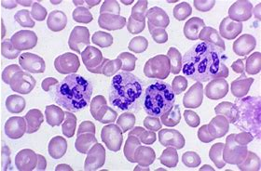](http://www.bing.com/images/search?view=detailV2&ccid=n7uL/RHA&id=5BB2D25860440B37D68C403B18B0885C91E9F840&thid=OIP.n7uL_RHAQRqVL1AFWjLf6AHaE3&mediaurl=https://pamadaydotnet.files.wordpress.com/2016/03/hypersegmented-neutrophils.png&exph=341&expw=519&q=Segmented+Neutrophils&simid=608044428623744834&selectedIndex=8)

### **Band Neutrophils** A left shift in the neutrophils is said to be present if the recorded differential count or a scan of the film indicates the presence of 5% or greater of band neutrophils **and** any less mature granulocytes. APS will continue to separate bands from neutrophils in our differentials.

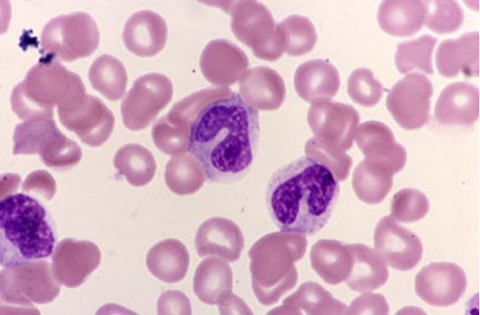

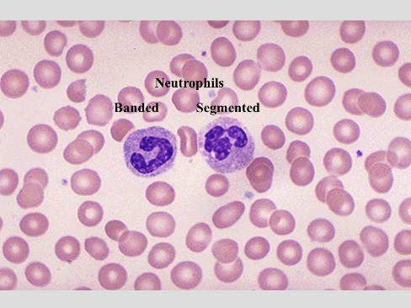

### **Metamyelocytes** A metamyelocyte usually has a central or eccentric, indented kidney bean nucleus. The chromatin is usually coarsely clumped, and there is no nucleolus; the N:C ratio is 1.5:1 to 1:1. The abundant, pink or colourless cytoplasm may contain rare reddish-purple azurophilic (primary) granules and/or many fine, lilac, neutrophilic (secondary/specific) granules.

### See the source image

## Qualitative abnormalities in myeloid cells

### **Auer rods**

A sharply deﬁned red rod or needle-like cytoplasmic inclusion formed by abnormal primary granule development. Found mainly in leukaemic myeloblasts or abnormal promyelocytes, they stain positively for myeloperoxidase and are a speciﬁc marker for myeloid lineage neoplasms. There may be several in a cell and maybe arranged in bundles (faggots). Report the absence or presence of auer rods.

1. Auer rods

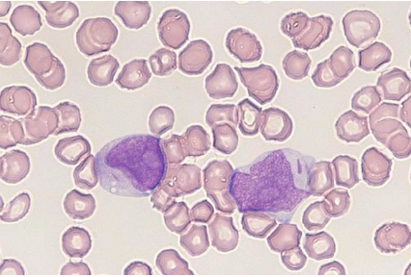

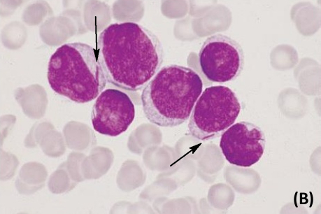

### **Döhle bodies**

Döhle body. Pale light blue or grey, single or multiple, cytoplasmic inclusions found near the periphery of the neutrophil. Döhle bodies are a non-speciﬁc reactive change but may also indicate May-Hegglin anomaly if associated with thrombocytopenia and giant platelets. Döhle bodies may also be seen in patients on growth factor therapy such as granulocyte colony-stimulating factor (G-CSF).

### **Granulation**

Coarse, purple staining primary (azurophilic) neutrophil cytoplasmic granules which occur as a response to infection and inﬂammation. A non-speciﬁc reactive change, it is a result of abnormal primary granule maturation with retention of their azurophilic staining properties.

1. Hypergranulation (toxic granulation) as in neutrophils

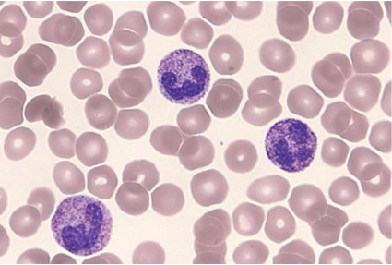

Reduced or absent neutrophil granulation causing the cytoplasm of mature neutrophils to appear blue-grey.

1. Hypogranulation as seen in myelodysplasia

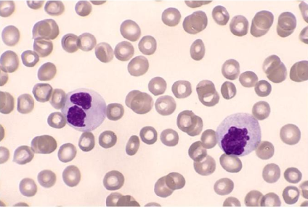

### **Vacuolation**

**Neutrophil cytoplasmic vacuolation** in infection is due to granule fusion with a phagocytic vacuole and release of lysosomal contents to kill bacteria. This vacuolation may appear as ‘pin-hole’ vacuolation – small, discrete vacuoles, but the vacuoles may be larger. Other causes of neutrophil vacuolation include alcohol toxicity and prolonged exposure to EDTA anticoagulant (storage artefact). **Monocyte vacuolation is not commented on.**

**Intra-cellular bacteria must be referred to a pathologist immediately.**

Image of neutrophil vacuolation and intra-cellular bacteria

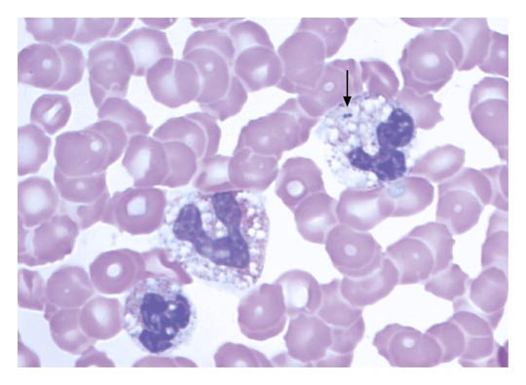

## FIRST PRESENTATION OF NEW LEUKAEMIA

On a first presentation of leukaemia, a differential should be performed and the blasts should be described and counted in the differential. This description should include:

Size N:C ratio Nuclear shape

Pleomorphism Nucleoli prominence Number of Nucleoli

Auer Rods (present or not) Chromatin pattern % of blast cells seen

Basophilic cytoplasm Cytoplasmic vacuolation Cytoplasmic granulation

**Acute Promyelocytic Leukaemia.**

The recommendation is to count these abnormal promyelocytes as blast equivalents in the differential but it is important that a suitable description of the abnormal promyelocytes and an interpretive comment is added to the ﬁlm report and a likely diagnosis of APML communicated directly to the clinician. APS will count APL cells that look like blasts as blasts and count further differentiated cells as promyelocytes onwards.

**Acute Monocytic Leukaemia.**

The recommendation is to count promonocytes in the differential and comment

on their presence with a suitable interpretive comment. Leukaemic promonocytes

should be summated with blast cells when making a diagnosis of AML.

**Monoblasts** are larger than myeloblasts (20-30 µl), with a round/oval nucleus, ﬁne chromatin and one or two prominent nucleoli. The cytoplasm is basophilic and usually lacks granules.

**Promonocytes** may be rarely seen in the peripheral blood in reactive conditions as well as in some leukaemias. They are large cells with a nucleus that is convoluted/indented with a delicate, lace-like chromatin pattern and prominent nucleolus. The cytoplasm is blue-grey and may contain a small number of ﬁne red-violet granules.

1. Monoblasts and promonocytes

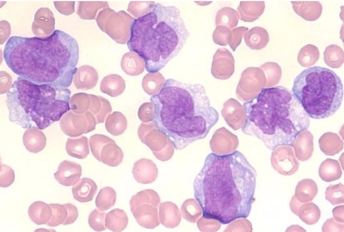

Monoblast

Monoblast

Promonocytes

## Platelets

A normal platelet measures 1.5–3 µm in diameter. Large platelets measure 3–7 µm (roughly the diameter of a normal sized red cell), whilst giant platelets, are larger than normal sized red cells at 10–20 µm in diameter and are ﬂagged by automated analysers. In a normal person, usually less than 5% of the platelets appear large. Platelet size increases gradually during storage in EDTA anticoagulated venepuncture tubes.

The validity of the platelet count must be checked visually and be consistent with the machine count. Occasionally platelets stain poorly and it is difficult to identify them with certainty. Try re-staining with aerospray, quick-diff or May Grunwald Giemsa stain again.

**Platelet clumping**

A false low platelet count and a reduction in film platelet numbers may be due to in vitro platelet clumping; the tail of the film should be checked for platelet clumps and/or fibrin strands and the EDTA specimen tube checked for clots. If platelet clumping is present on the film delete the numerical number and report as “CLUMPED”. Report an estimate in the blood film as decreased in number, normal in number or increased in number.

**Enumeration comments**

Comments on platelet numbers should be limited to

"Thrombocytopenia" if platelet count is <140 x 10^9/L

"Thrombocytosis" if platelet count is >500 x 10^9/L

“Borderline platelet count” between 140 and 150 x 10^9/L.

Blood Film Estimation.

When estimating the platelet count due to unreliable automated count. Report a range of platelets with the following comment.

**Blood film platelet count estimated to be “x”-“x” x10*9/L.** (Using the ^ symbol will terminate your film comment and delete everything beyond it when transferring to cerner)

**Fibrin strands**

Fibrin stands may indicate clotting of the FBE EDTA sample and may include platelet clumps. A fibrin strands comment may be appropriate and a review of any coagulation results for sample activation.

**Large platelets, Giant platelets and megakaryocytic cells**

Commenting on large and giant platelets should take into account the clinical context eg Reactive (bleeding), proliferative (malignant), hereditary (May Hegglin) or acquired (splenectomy).

It is recommended that giant platelets be graded and that a comment about the presence of megakaryoblasts, megakaryocytes and micro-megakaryocytes or bare megakaryocyte nuclei be made if seen in the PB ﬁlm.

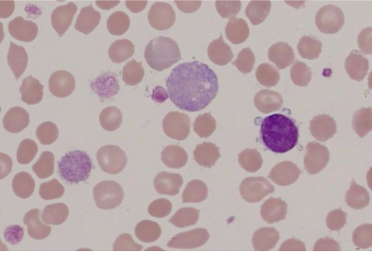

Giant platelet

Giant platelet

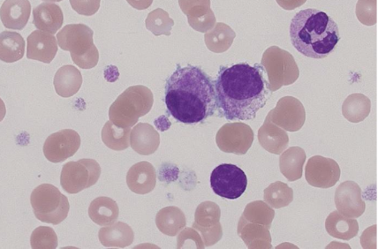

Bare megakaryocyte nuclei

Micromegakaryocytes

**DOCUMENT HISTORY**

|  |  |  |  |  |  |  |  |  |  |
| --- | --- | --- | --- | --- | --- | --- | --- | --- | --- |
| **Version** | **Issued** | | **Contributors** | | **Description of Changes Made** | | | | **Authorised by (name)** |
| 3.1 | 25/09/2014 | | Grant Rowley | | Update PathNet | | | | W.OSBORN |
| 3.2 | 22/02/2019 | | Wendy Osborn  Steven Schischka | | Updated to reference from ICSH recommendations for the standardisation of nomenclature and grading of peripheral blood cell morphological features (2015) | | | | S.SCHISCHKA |
| 3.3 | 25/01/2021 | | Steven Schischka | |  | | | | S.SCHISCHKA |
| *Signed:* |  | | | | | | | | |
|
| **Copy Storage Locations (Name of the Manual)** | | | | | | | | | |
| **Copy 1:** | | Morphology Manual | | **Copy 2:** | |  | **Copy 3:** |  | |